Possible language scaffolds for maths skills - Year _____
Skill | Possible prompts
  Finding the anchor | ________________________________ is useful first because…  __________ must be because…
  Conjecturing | I think… because…  _____ might be… because…
  Reasoning logically | This must be…because…  This could be…because…
  Looking for/ using a pattern | _______ is interesting because…
  Trial and improvement | This might be better…  Next I could try…
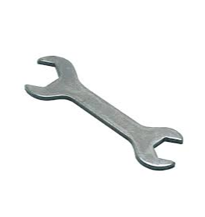  Working systematically | The next logical place to go is…  Now I have unlocked ____
  Generalising | I can never have…  I will always need…  Every answer must be…
  Proving | For example…  …because…  If I use my answer I can show that…

